In the following questions we will ask you for your views on future economic growth. For your reference, the following chart shows the mean annual growth rates of world GDP per capita by decade over the past five centuries.

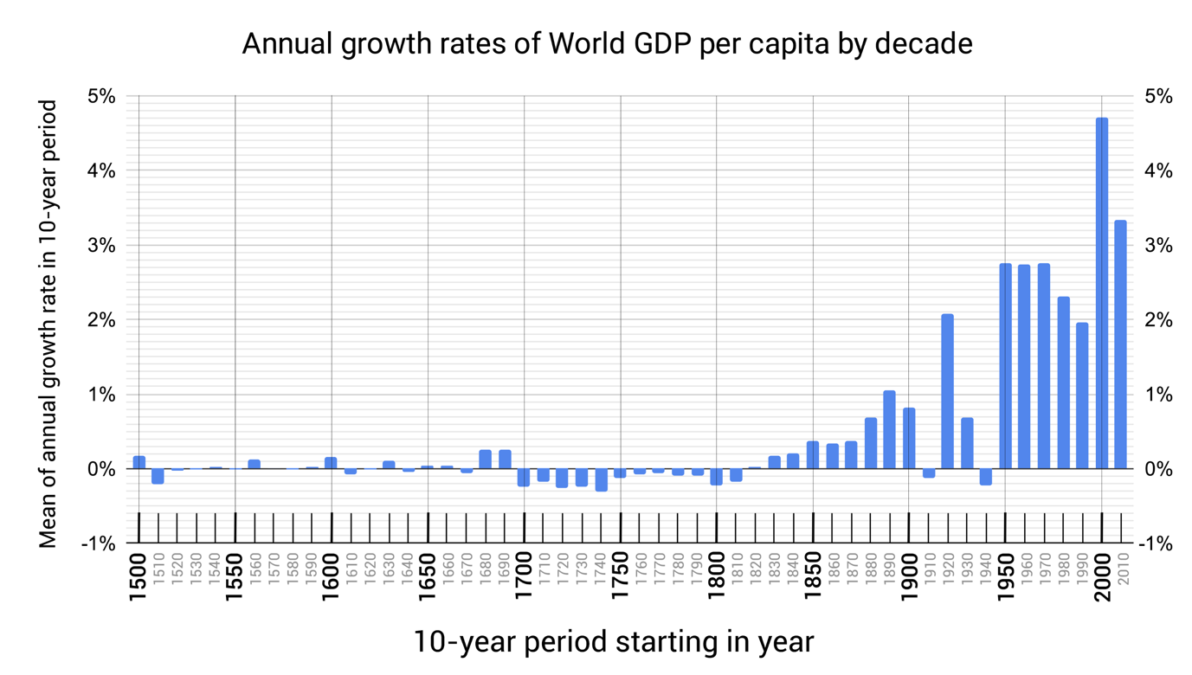

Source: Maddison Project Database 2020: 1500-2018

If you want to look at a larger version of the graph you can click [here](https://ndreksler.github.io/github.io/Economist%20Survey%202021/Growth%201500-2018%20v1.png) (opens in new window).  
  
The annual growth rate over the period 1500-2018 was 0.49%. The mean annual growth rate of world GDP per capita over different periods can be seen below:

| **Period** | **Mean annual growth rate** |
| --- | --- |
| 1500-1820 | -0.04% |
| 1820-1920 | 0.39% |
| 1920-2018 | 2.31% |